# Application development

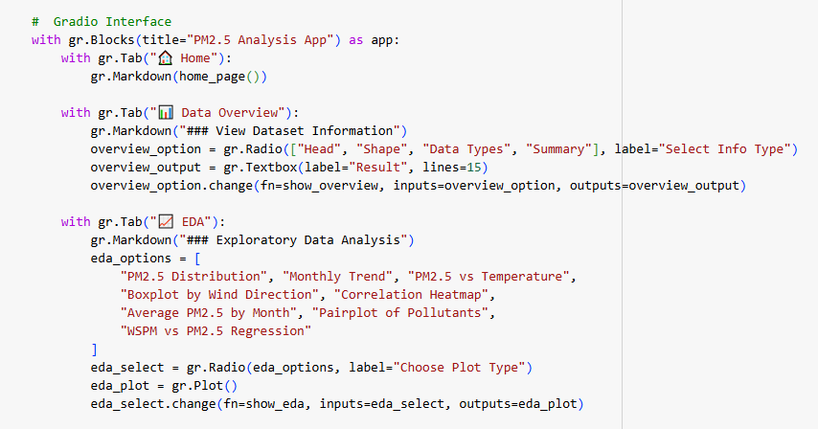

**Figure 21: Gradio interface creation**

(Source: Google colab)

The code given here describes how to build a Gradio application for ML models to predict the PM2.5 levels. The application enables the user to look up weather and pollutant data to be able to make a prediction of the level of air pollution. The different parts of the interface are data preview, EDA and a model prediction section where the user can choose whether to use a linear regression model or a random forest model. The mobility of the application involves a database containing weather and air quality pollutants, and it is easy to use to make predictions about PM2.5 concentration.

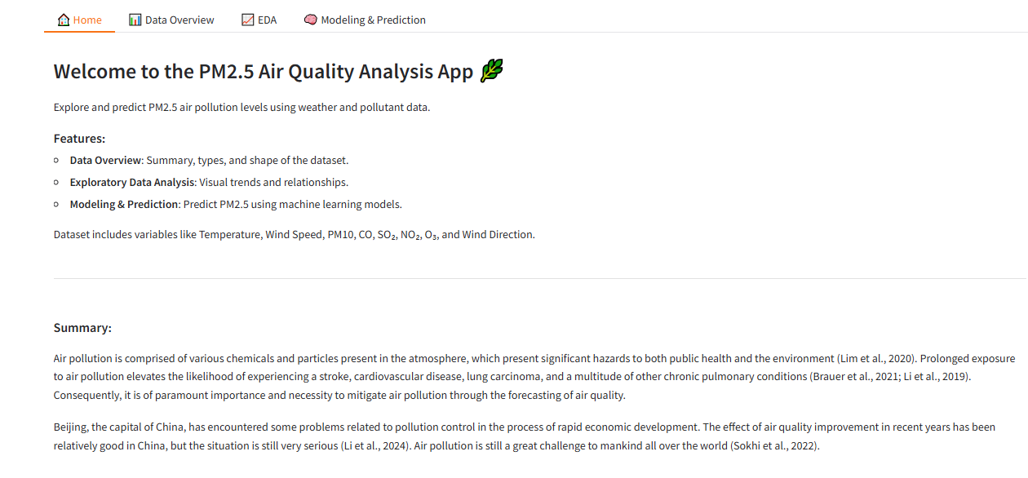

**Figure 22: Gradio interface**

(Source: Google colab)

The gradio developed interface offers different options to users to visualise air pollution data, as well as the prediction of PM2.5 levels by using machine learning. It involves the use of data summaries, EDA plots and model predictions in forecasting the quality of air.

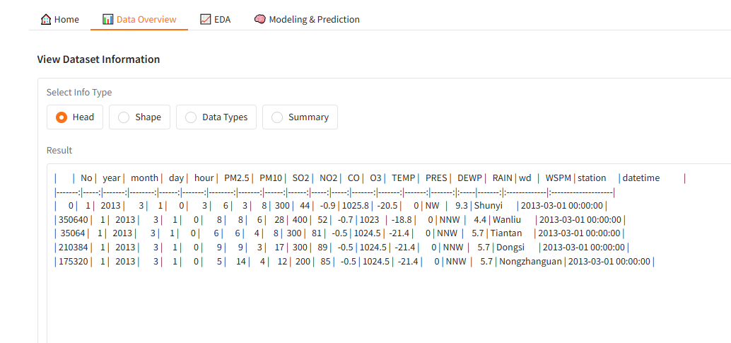

**Figure 23: Gradio interface dataset overview**

(Source: Google colab)

The Gradio interface also provides approximately all general information about the dataset of the features and their types aims to maximize the user experience.

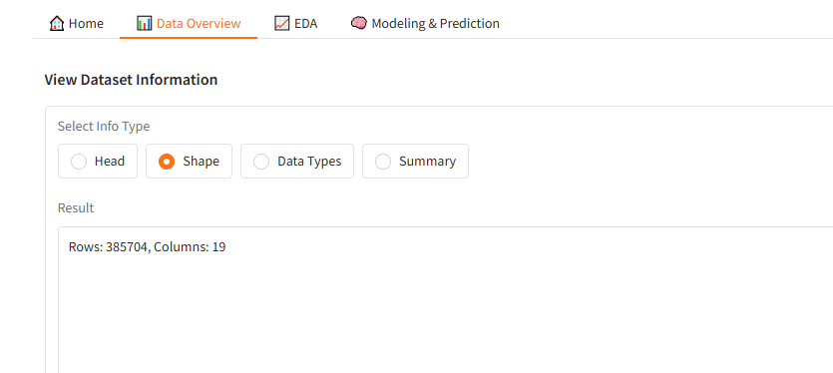

**Figure 24: Gradio interface dataset shape**

(Source: Google colab)

The interface in Gradio also allows showing the shape of the given dataset and the total number of rows and columns is shown to provide the user with an idea of the dataset size and the way it is arranged.

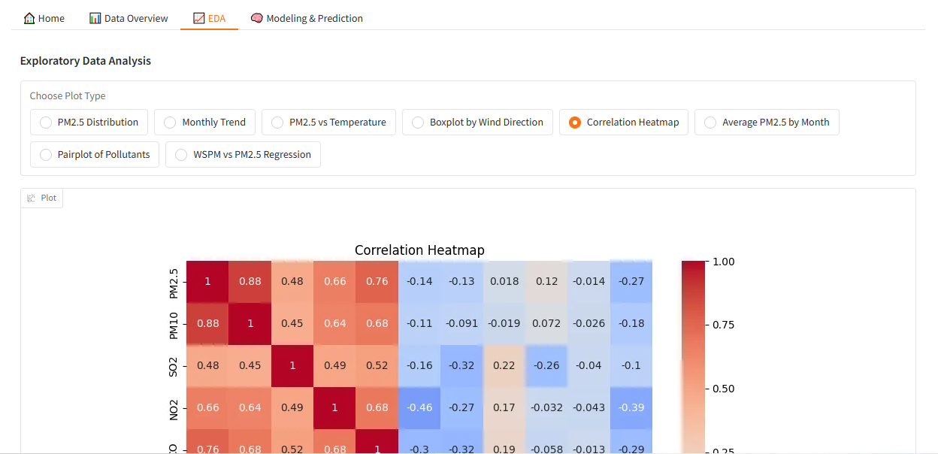

**Figure 25: Gradio interface showing visualisation**

(Source: Google colab)

The Gradio interface also provides the features such as distributions or relationship that exists within the data set where the user can visually analyze the data set for further deeper analysis or interpretation.

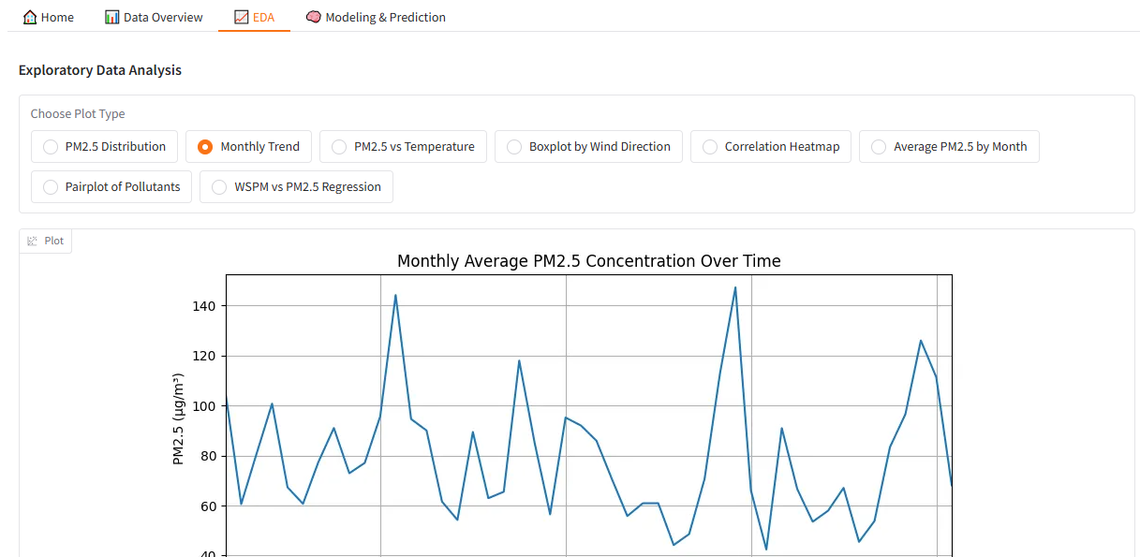

**Figure 26: Gradio interface showing visualisation**

(Source: Google colab)

Another type of Gradio visualisation is the ones that pertain to Relations, which can be seen as a line plot that gives the users an insight into how two features are related in the dataset.

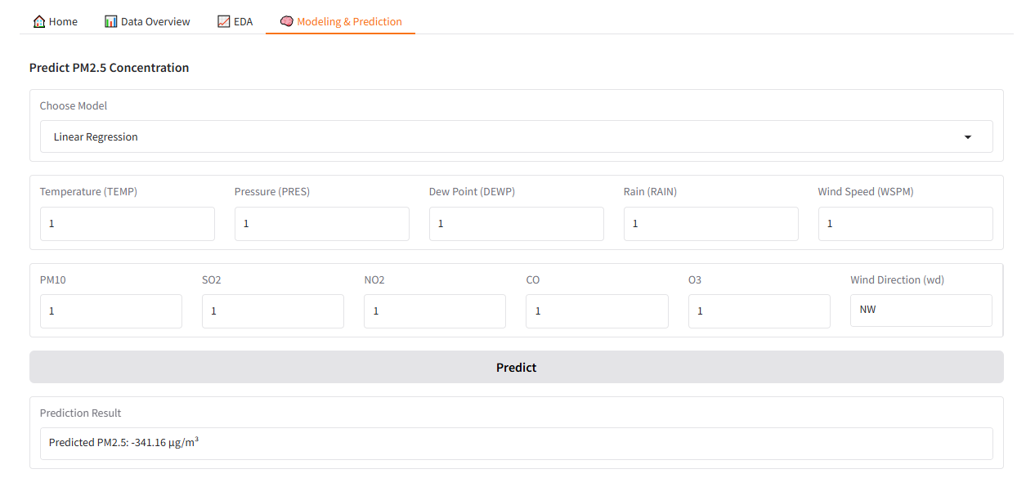

**Figure 27: Gradio interface showing linear regression prediction**

(Source: Google colab)

The Gradio interface provides dynamic predictions regarding the PM2.5 level based on configurable variable values to explain linear regression predictions in a more interactive model for air quality.

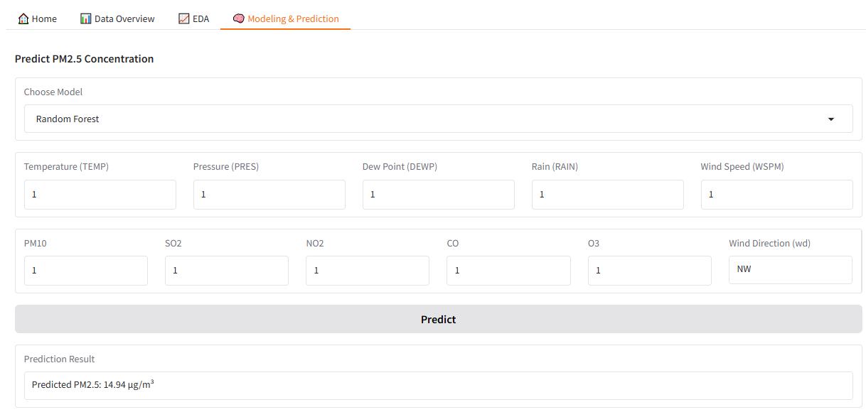

**Figure 28: Gradio interface showing Random Forest prediction**

(Source: Google colab)

The Gradio interface enables presenting the decision made with the help of the Random Forest model, and thus presents an alternative to choosing an ML algorithm to predict PM2.5 levels using selected attributes.